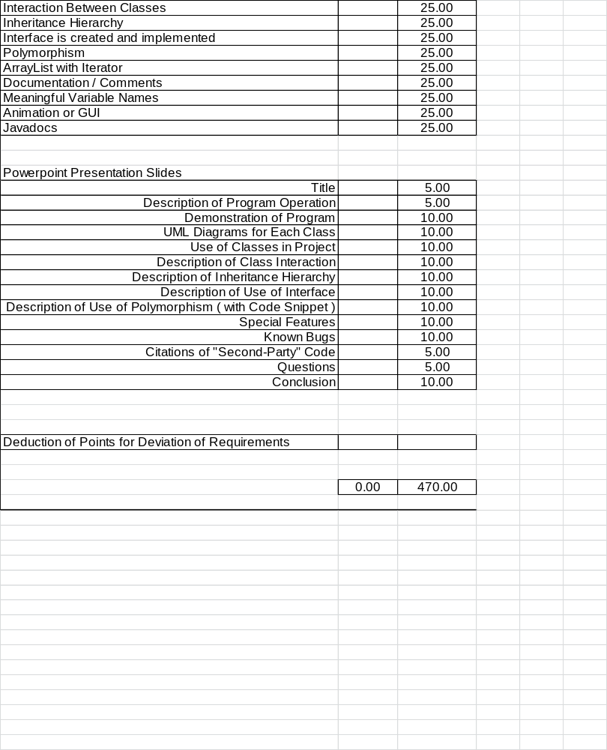 Computer Science 3 Project I
Mr. Mayo
Spring

1. This project is worth 470 points
2. The program must include the following 14 items. Each item is worth 25 points.
1. Wrapper classes – Integer AND Double ( with intValue(), doubleValue() methods )
2. Relational (==, !=, >, >=, <, <=) and Logical Operators ( &&, ||, !) - at least 5 total
3. One or more “if-then-else” statements
4. One or more “while/for loops”
5. At least ONE interface and THREE classes (one of which MUST be abstract), not including class Test in “Test.java” – which brings the total to FIVE.
- Interaction between all four classes/interfaces (i.e. each class must interact with AT LEAST one other class (not-including class Test in “Test.java”)
7. An Inheritance hierarchy must be implemented with the student-designed classes (i.e. not
the actionListener interface)
8. At least one interface must be implemented with student-designed classes.
9. Polymorphism must be implemented with the student designed classes.
10. Class ArrayList must be used in at least ONE student designed class and it MUST be traversed through AND accessed via an Iterator.
11. Comments explaining logic and operation of program at “key points”
12. Animation OR Graphical Interface must be implemented
13. Meaningful variable names
14. “javadocs” must be created for your project (n.b. each method should be commented according to javadoc specifications)

Subtotal = 350 points

3. Some ideas for projects are:
- Blackjack (or any card game) - Bowling
- Hangman - Yahtzee
- Monopoly - Backgammon
- Jeopardy - Othello
- Wheel of Fortune - (Chinese) Checkers/Chess
- Basketball games - Connect Four
- Football games - Missile Command
- Risk - Life

- The Final Project is due on your assigned lottery date. ONE HUNDRED (100) POINTS WILL BE DEDUCTED FOR LATE PROJECTS.

- A Powerpoint Presentation/Podcasts should be given on your lottery date. The presentation will be worth 120 points. The presentation shall have, at minimum, the following slides:
- Title
- Description of program operation (or how game is played)
- Demonstration of Program (Task switch from Powerpoint presentation to your program using Alt-Tab)
- UML Diagrams for each class
- Use of classes/objects in project - elaborate on how classes represent physical objects in your program (be prepared to justify class names, class data member names, class method names…)
- Description of class interaction (be prepared to talk about which classes create each of the other classes)
- Description of use of an inheritance hierarchy (be prepared to justify structure)
- Description of use of an interface (be prepared to justify its use with other classes)
- Description of use of polymorphism (include a code snippet that demonstrates polymorphism)
- Special features implemented in program - elaborate on tricks/special things you did
- Known bugs in program
- Citation of “second-party” code used in program (be able to explain code)
- Conclusion - Summary of what you thought of writing the program
i. Difficulty level,
ii. "Fun" level,
iii. Your evaluation of the final product,
- What you learned (be specific)
- Questions? (this is simply a slide that says “Questions?” that keys the audience for any questions they might have)

Subtotal = 470 points

Point Distribution
Requirements 1-12 350 points
Powerpoint Presentation 120 points

(There will be a -5 points EACH misspelling or grammatical error)

Total points 470 points

Pointers for your final project:
- Make sure you have all files on the presentation day!!
- Make sure you have MANY copies of your project with powerpoint presentation, source code and executable file (you can never have too many copies).
- Test your program on the presentation computer before the presentation date.
- Use of block comments ( /* */ ) for commenting large sections of code.
- Using System.out.println statements to display values during the debugging process.
- MAKE BACKUPS OF YOUR WORK!!

- And, of course,…
HAVE FUN :-) !!

